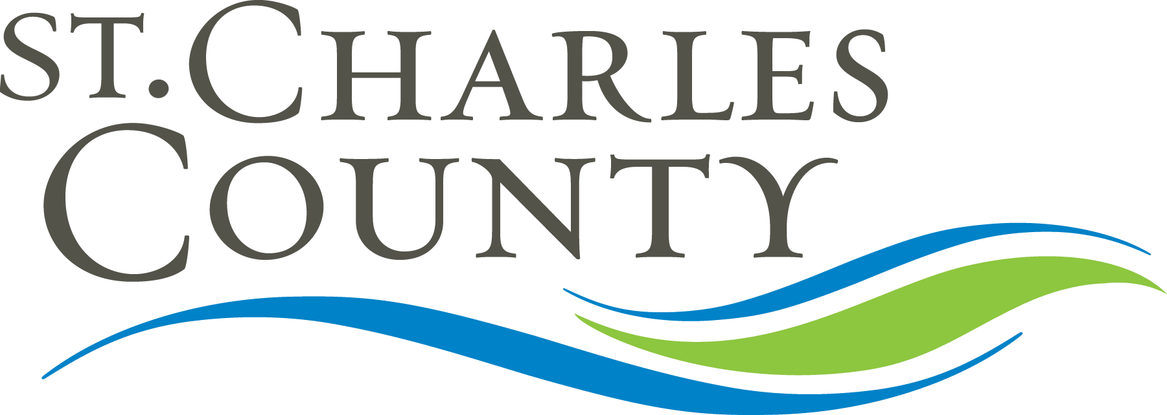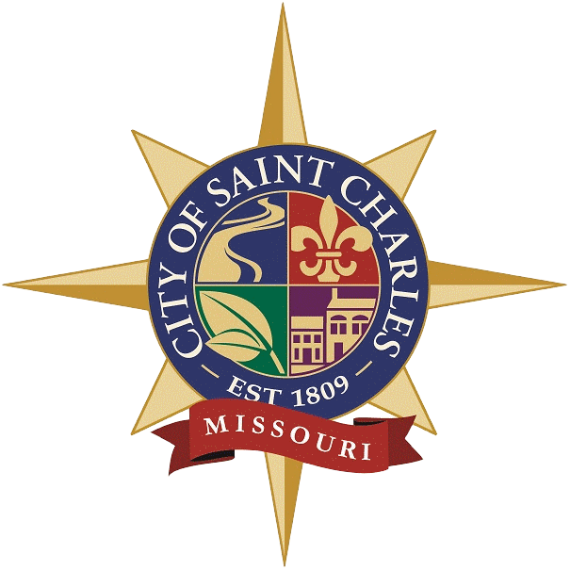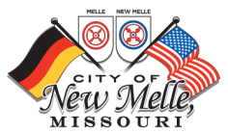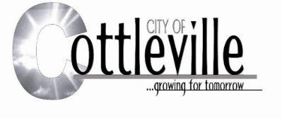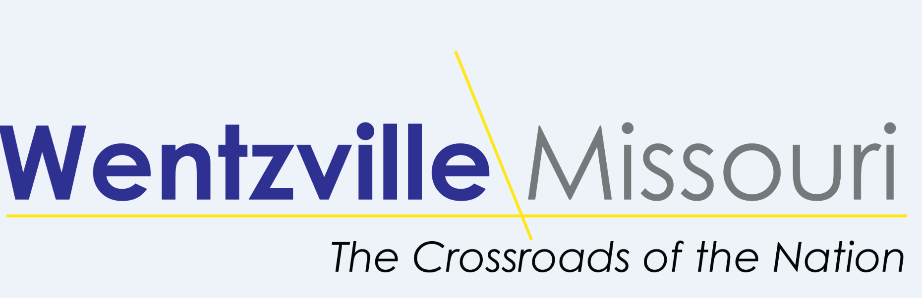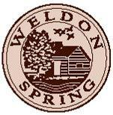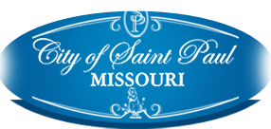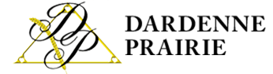

PUBLIC NOTICE
ST CHARLES URBAN COUNTY
Public Comment Period for St Charles Urban County’s Community Development Block Grant (CDBG) Program Year FY2021 Consolidated Annual Performance Evaluation Report (CAPER)
City of St Charles, City Hall
200 N Second Street
St Charles, Missouri 63301
5:00pm

PUBLIC NOTICE IS HEREBY GIVEN that a Public Hearing will be held on Wednesday, March 17, 2021 at 5:00 pm at the City of St Charles City Hall First Floor concerning the Fiscal Year 2021 Consolidated Annual Performance and Evaluation Report for the St Charles Urban County Community Development Block Grant Program.
The 2021 CAPER will be available in draft form for review by any interested citizen prior to submission to the U.S. Department of Housing and Urban Development starting on Monday February 28, 2022 during regular office hours of 8:00am to 5:00pm Monday through Friday in the St Charles County Administration Building, in the Office of Community Development 201 N Second Street, Ste 410, on the website at www.sccmo.org and available in City of St Charles, Department of Community Development 200 N Second Street, Ste 303, on the website at www.stcharlescitymo.gov.
All public comments will be included with the final CAPER that will be submitted to HUD on or about March 25, 2022. Please forward written comments by March 23, 2022 at 5:00pm to Kathleen Thompson, Dept of Community Development, 200 N 2nd Street, Ste 303, St Charles, MO 63301 or you may email comments to cdbg@stcharlescitymo.gov.

